1. **Issues and concerns:**This feature allows you to add any issues and concerns that need attention.

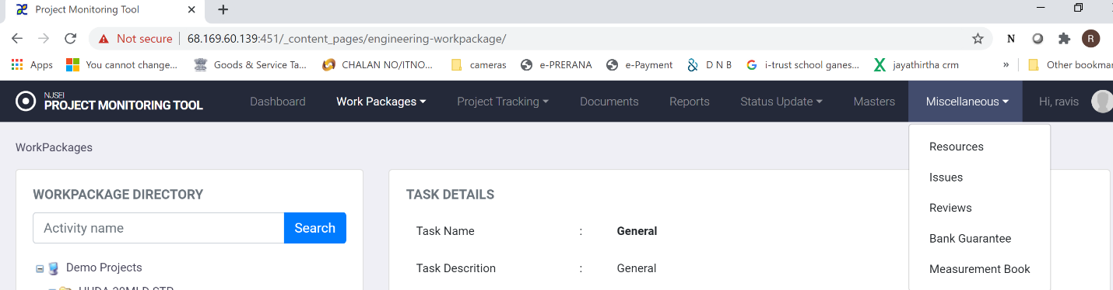

To use this functionality,

1. Choose “Miscellaneous” in main menu.
2. Click on “Issues”.
3. You will see following screen.

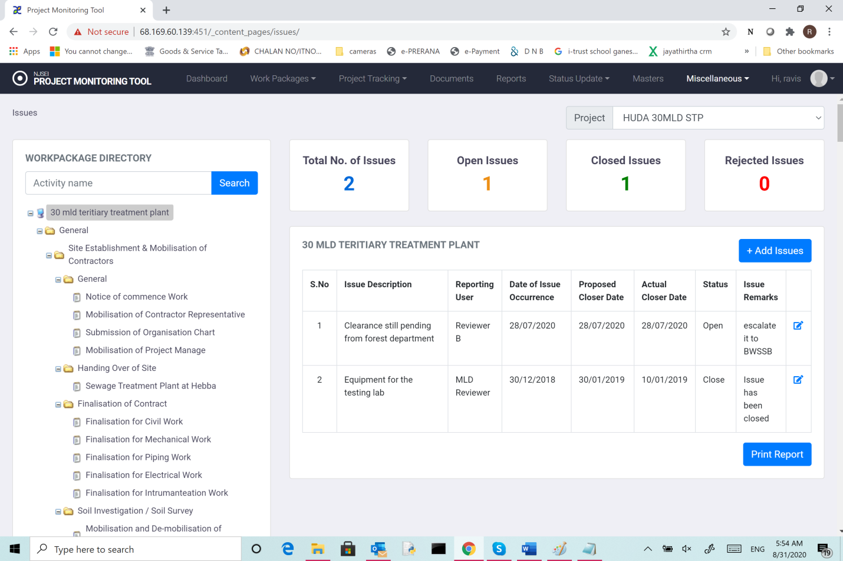

This shows details of issues flagged for any chosen task/sub-task.

1. Total no of issues,
2. Open issues,
3. Closed issues,
4. Rejected issues
5. Table describing issues
6. Serial number,
7. Description,
8. Date of issue occurrence
9. Proposed closure date
10. Actual closure date
11. Status
12. remarks (for latest status).

**9.1 Add Issues:**

1. Choose “Miscellaneous” in main menu.
2. Click on “Issues”.
3. In the displayed screen (shown above), Click “Add Issues”.
4. You will see following screen.

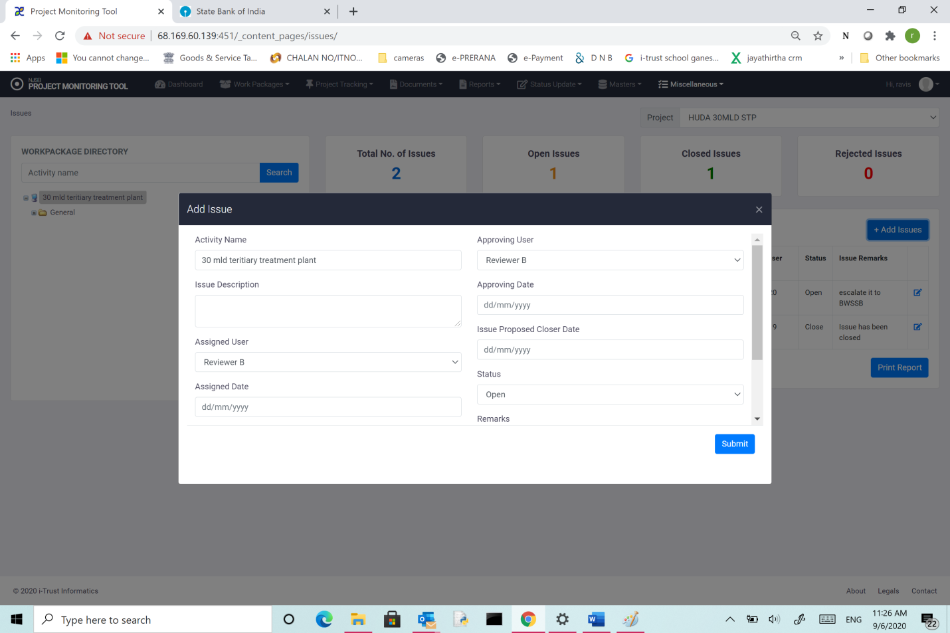

Enter the following data:

1. Activity Name,
2. Issue description,
3. Assigned user : Choose from option provided which user you want to assign this issue to.
4. Assigned date: Date of assignment.
5. Reporting user : Choose from option provided which user reported the issue.
6. Reporting date: Date of reporting.
7. Approving user : Choose from option provided which user can approve closure when issue is closed.
8. Approving date: Date of reporting.
9. Proposed date of closure.
10. Current status (when entered this should be “Open”).
11. Remarks (if any) .
12. Click Submit.